**Lab 2**

**Part 1**

For Ncyc=5:

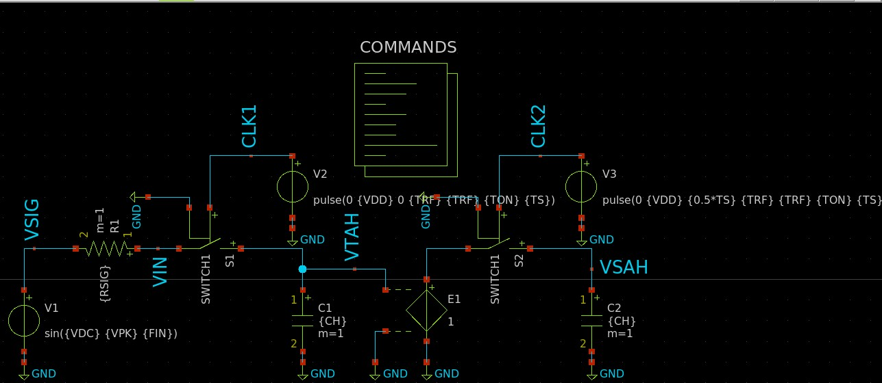

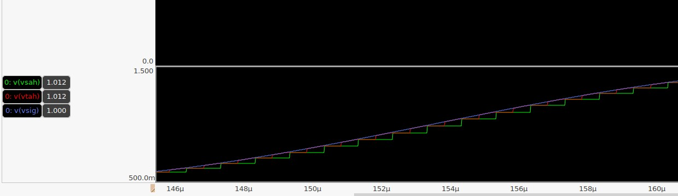

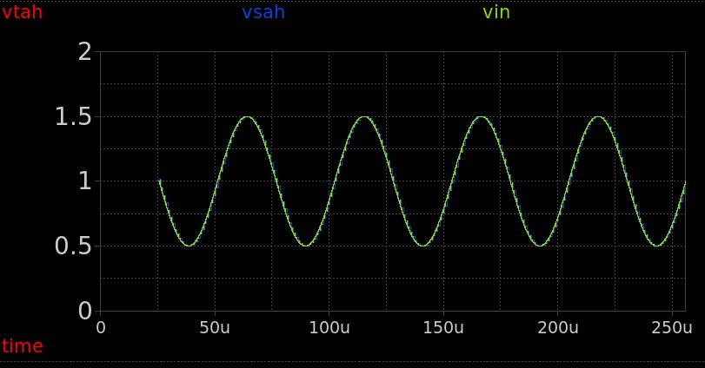

FFt

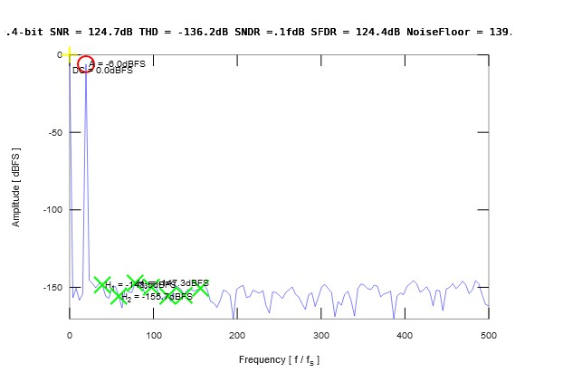

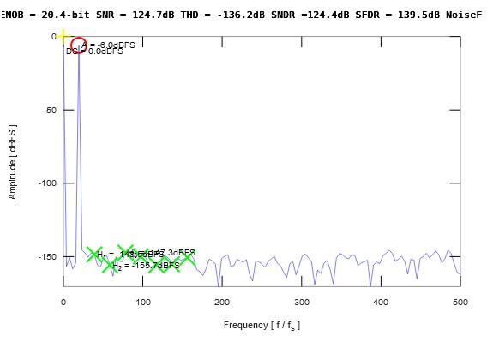

**What is the power of the peak signal (in dB)? Why?**

DC COMPONENT = 0dB (1 in linear scale )

Single tone =-6dB (0.5 in linear scale )

Single tone is sin wave with power = A**2/2 =0.25/2=0.125

P=10log(0.125)= 9 dB

**How many bins are occupied by the test signal?**

1 bin

**What is the noise floor (in dBFS)?**

About 139 dBFS from plot

**What is the relation between the SNR, NFFT, Signal Power, and Noise Floor?**

Noise Floor (dB)=SNR​−10log10​(NFFT)

And SNR = (Signal Power/Noise power)

**If the sampling is ideal, what is the source of error that causes the noise floor?**

There is no leakage but noise floor can be because of quantization error if signal is digitalized or mathematical issues due to FFT

**Note that if you made the reltol and vntol options in the spice code smaller, ENOB will increase.Why?**

reltol and vntol control the numerical accuracy of the solver. When you decrease these tolerances the Effective Number of Bits (ENOB) increases.

When reltol and vntol are made smaller:

1. Reduced numerical noise: SPICE uses iterative solvers, and reducing tolerances minimizes rounding errors and convergence inaccuracies.
2. More accurate voltage calculations: This leads to less distortion in transient and frequency-domain simulations.
3. Lower simulation-induced noise: Since ENOB is affected by SNR, reducing numerical noise increases the SNR, thereby improving ENOB.

**FOR Ncyc = 5.5**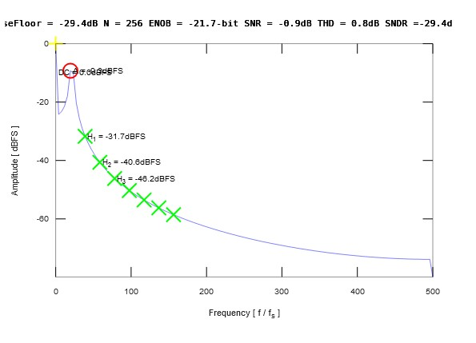

We can obseve the spectral leakage increasing the number of bins (nearly 7).

SNR decreased , noise floor is now about 75 dB as the specral leakage effet is added to the fft noise and quantization noise

**Part 2**

**Ncyc=5:**

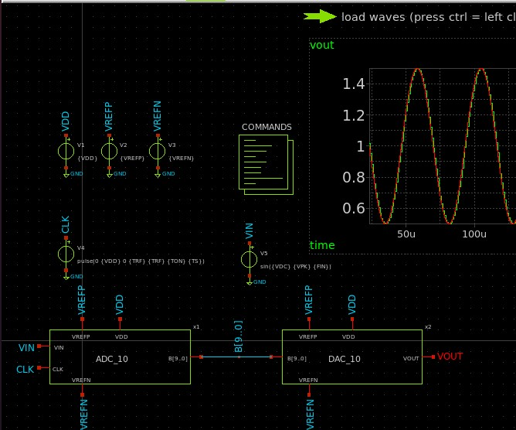

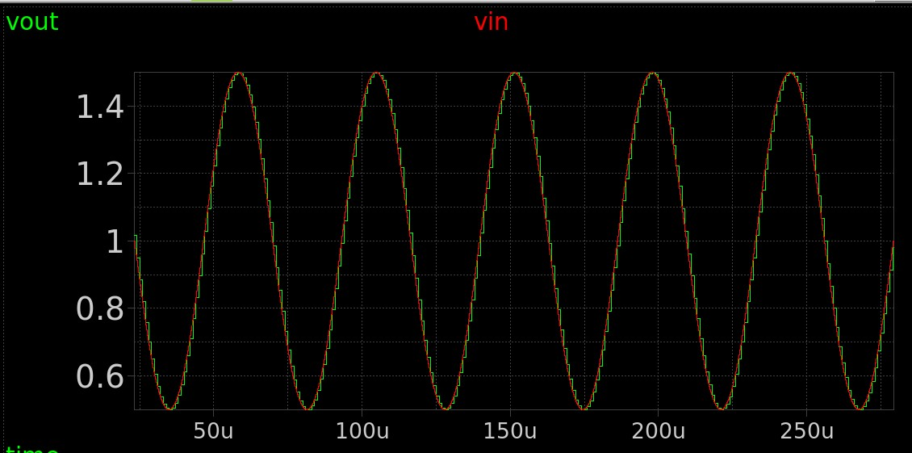

**FFT**

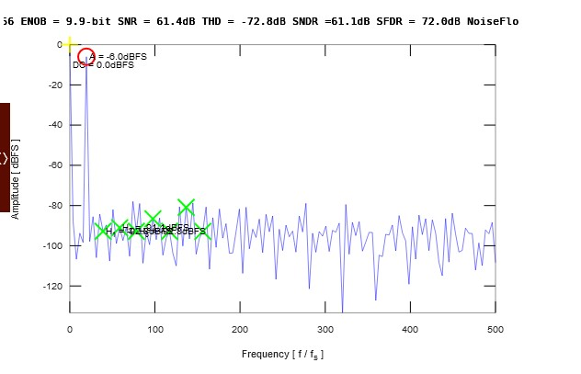

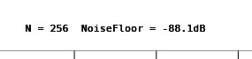

(3)When observing the timing analysis the two signals are continuous in time but we can say that the quantized signal is discrete as it takes the shape of steps

**(5) SNR**

from plot : SNR = 61.4 dB

analytically : SNR = 6.02*10+1.76 = 61.96 dB

**ENOB**

from plot : ENOB =9.9 bit

analytically : ENOB = (SINAD-1.76)/6.02 = (61.1-1.76)/6.02 = 9.85 bits

**SIGNAL POWER**

DC COMPONENT = 0dB (1 in linear scale )

Single tone =-6dB (0.5 in linear scale )

Single tone is sin wave with power = A**2/2 =0.25/2=0.125

P=10log(0.125)= 9 dB

**DC POWER**

from plot Pdc =0 db

analytically : Vdc = VDD/2 = 1V

Pdc = 10 log (1*squared) =0 db

**NOISE FLOOR**

From plot : noise floor = -88.1dB

Analytically : noise floor =SNR + 10log(M)= 61.96 + 10log(256) = 86.1 dB

**(6)SFDR = 72 dB (from plot)**

**For Ncyc = 4**

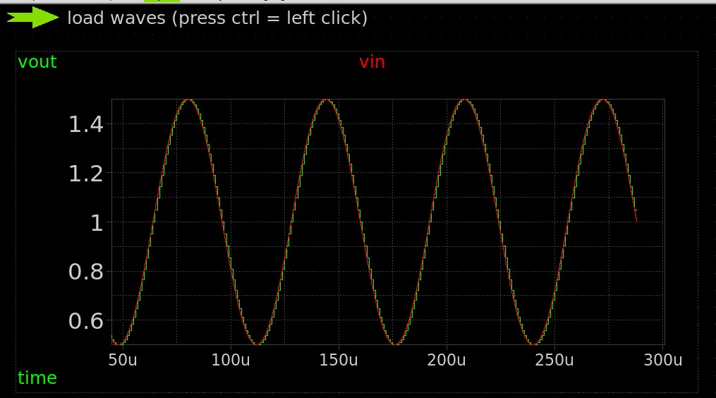

**FFT**

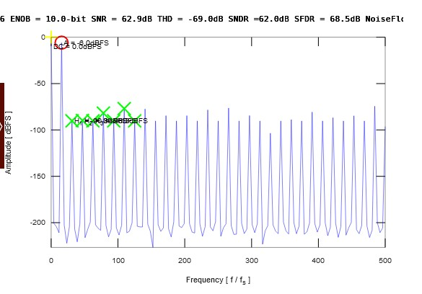



**New SFDR = 68.5 dB from plot**

Comment :

SFDR increased when Ncyc =4 as now (Ndft/Ncyc) is an integer number so the harmonics effect increased as the plot shows which lead to decreasing SFDR